**Real Estate Application Setup Document**

* **Hardwaredetails**

1. RAM : 2 GB
2. Hard Disk : 256 GB Minimum ( can be increased, depending on the size of Data base and application)
3. OS : Windows
4. Processor : I3 or above

* **Software to be installed**

1. JDK 8
2. Tomcat 7 or above
3. My SQL 5.6

**Steps to be followed to deploy war file and setup database**

**Step1:** Install all the required software’s to deploy application.

**Step 3:**Change database URL and credentials in \apache-tomcat-7\ webapp\WEB-INF/classes/ database.properties

1. database.url=jdbc:mysql://localhost:3306/real
2. database.username= Username
3. database.password= Password

Where

* localhost – IP of database system
* Username – user name of data base
* Password – Password of data base

For Example:-

* jdbc.url= jdbc:mysql://172.16.*.***:3306/real
* database.username=root
* [database.password=](mailto:jdbc.password=Chetu@123) root

**Step 4:** Create database in My SQL as **girasol.**

**Step 5:** Place Real_Estate_Buyer.war into \apache-tomcat-7\webapps.

**Step 6:** Start tomcat server from \apache-tomcat-7\bin\startup.bat, it will deploy the application into tomcat as well as create the database schema (tables).

**Step 7:** Start the application in browser and welcome page will open to register or login.

**Technologies Used:**

* Jdk 1.8
* Jsp
* maven
* My SQL 5.6
* Spring MVC
* Spring Core
* Spring Security
* Hibernate
* CSS
* Java Script
* J Query
* Liquibase
* Data base configured with some of the default properties and its details, we have to register as buyer for searching results.

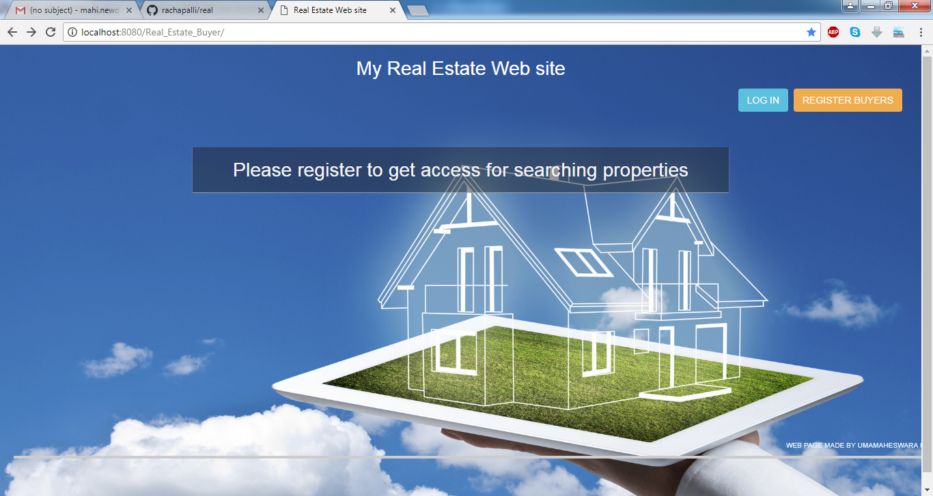

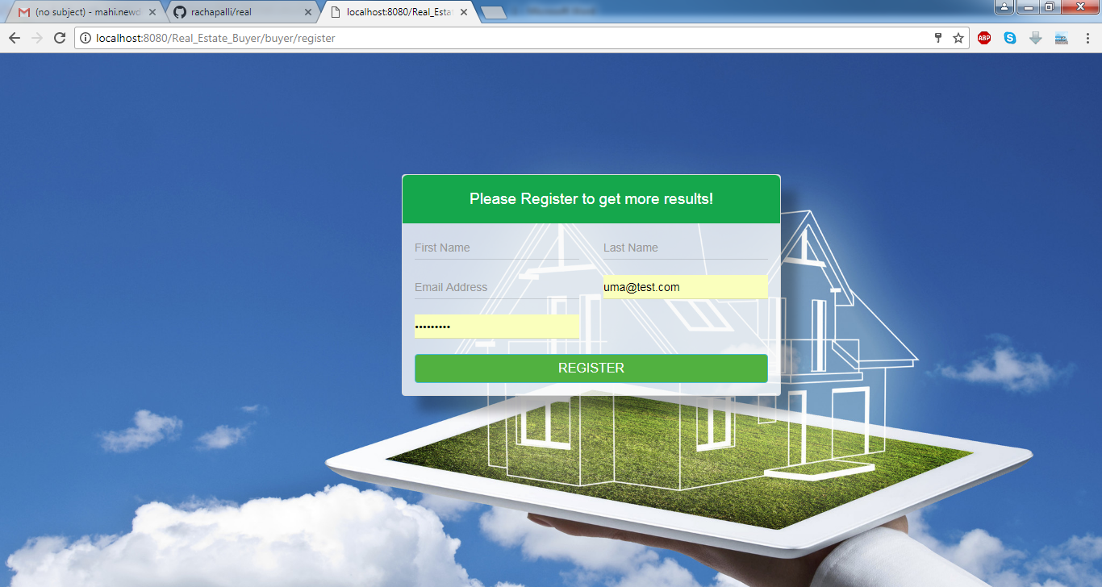

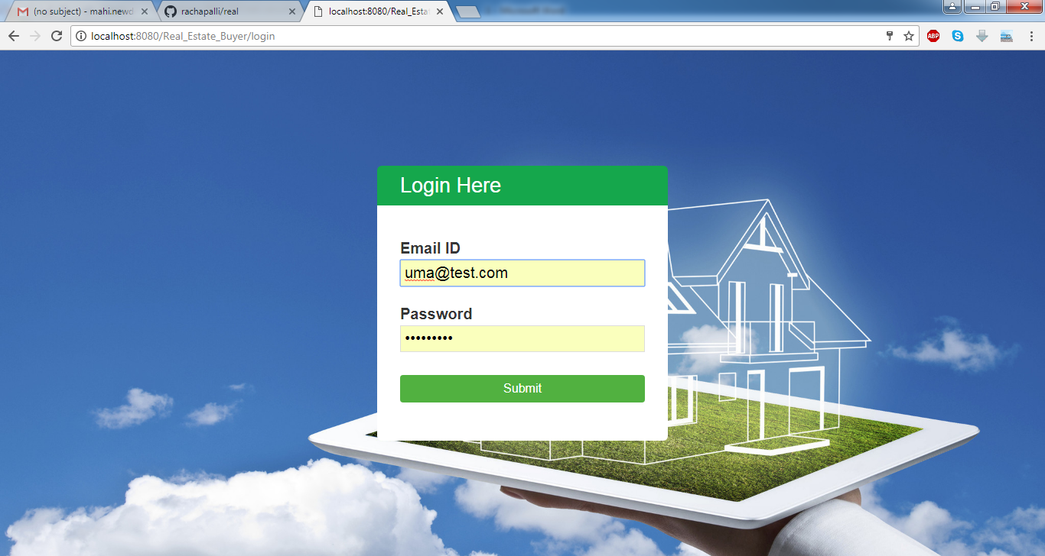

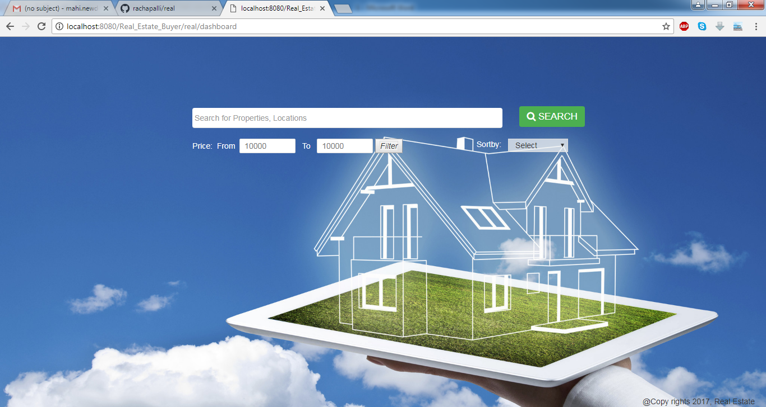 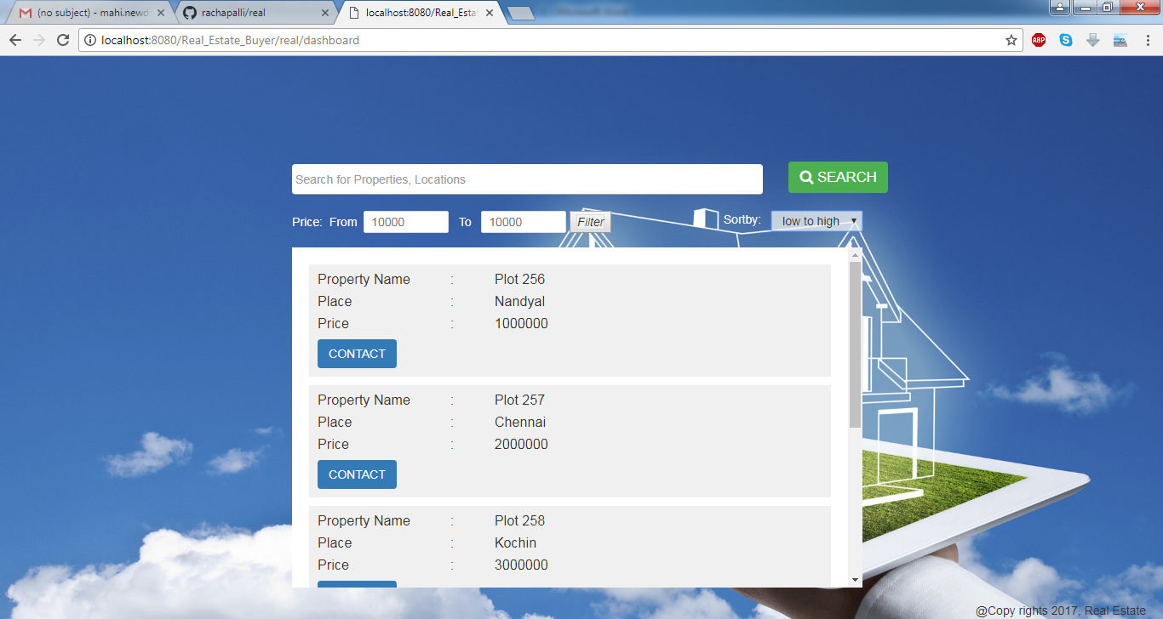

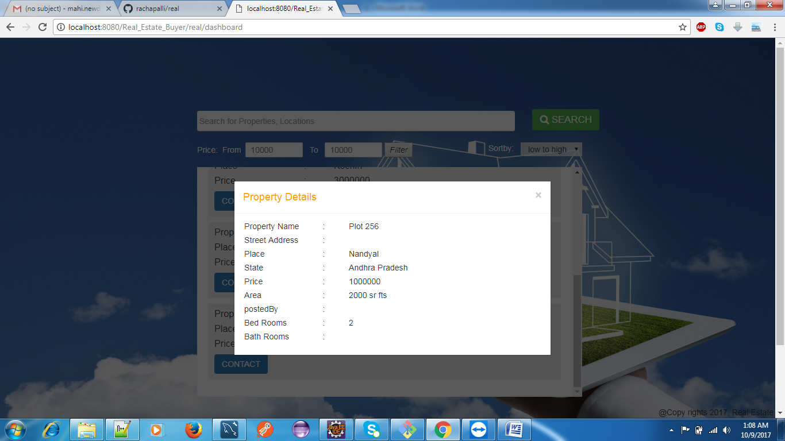**ER Diagram:**

